- We expect UK employment will dip slightly in the second half of this year, as job cuts in lower-paid parts of the private sector more than offset continued solid public sector job creation.
- Though we forecast a gradual recovery in private sector employment will take hold in 2026, it's unlikely to be strong enough to prevent unemployment drifting up towards 5%, from 4.5% in Q1 2025.
- Early data on the impact of the increases in employers' national insurance contributions and the national living wage in April suggest substantial job losses and falling vacancies in lower-paid sectors, such as accommodation and food. We think this is a one-off adjustment to the recent build-up in cost pressures rather than the start of a persistent decline in job numbers.
- The public sector has been responsible for nearly three-quarters of net job creation since 2019. This support is likely to weaken from next year as government departments adjust to tighter budgets.
- But public sector employment should continue to rise. The National Health Service accounts for more than a third of public sector jobs, and a combination of its political importance and its struggle to improve productivity mean its demand for workers will remain strong.
The labour market is a key source of uncertainty for the UK economy in 2025. We've already examined the key uncertainties, the challenges posed by data problems, and the implications of April's increase in employers' national insurance contributions in our series on labour market developments. In our final note, we examine the sectoral outlook for employment.
Chart 1: The squeeze on lower-paid jobs will cause total employment to dip this year
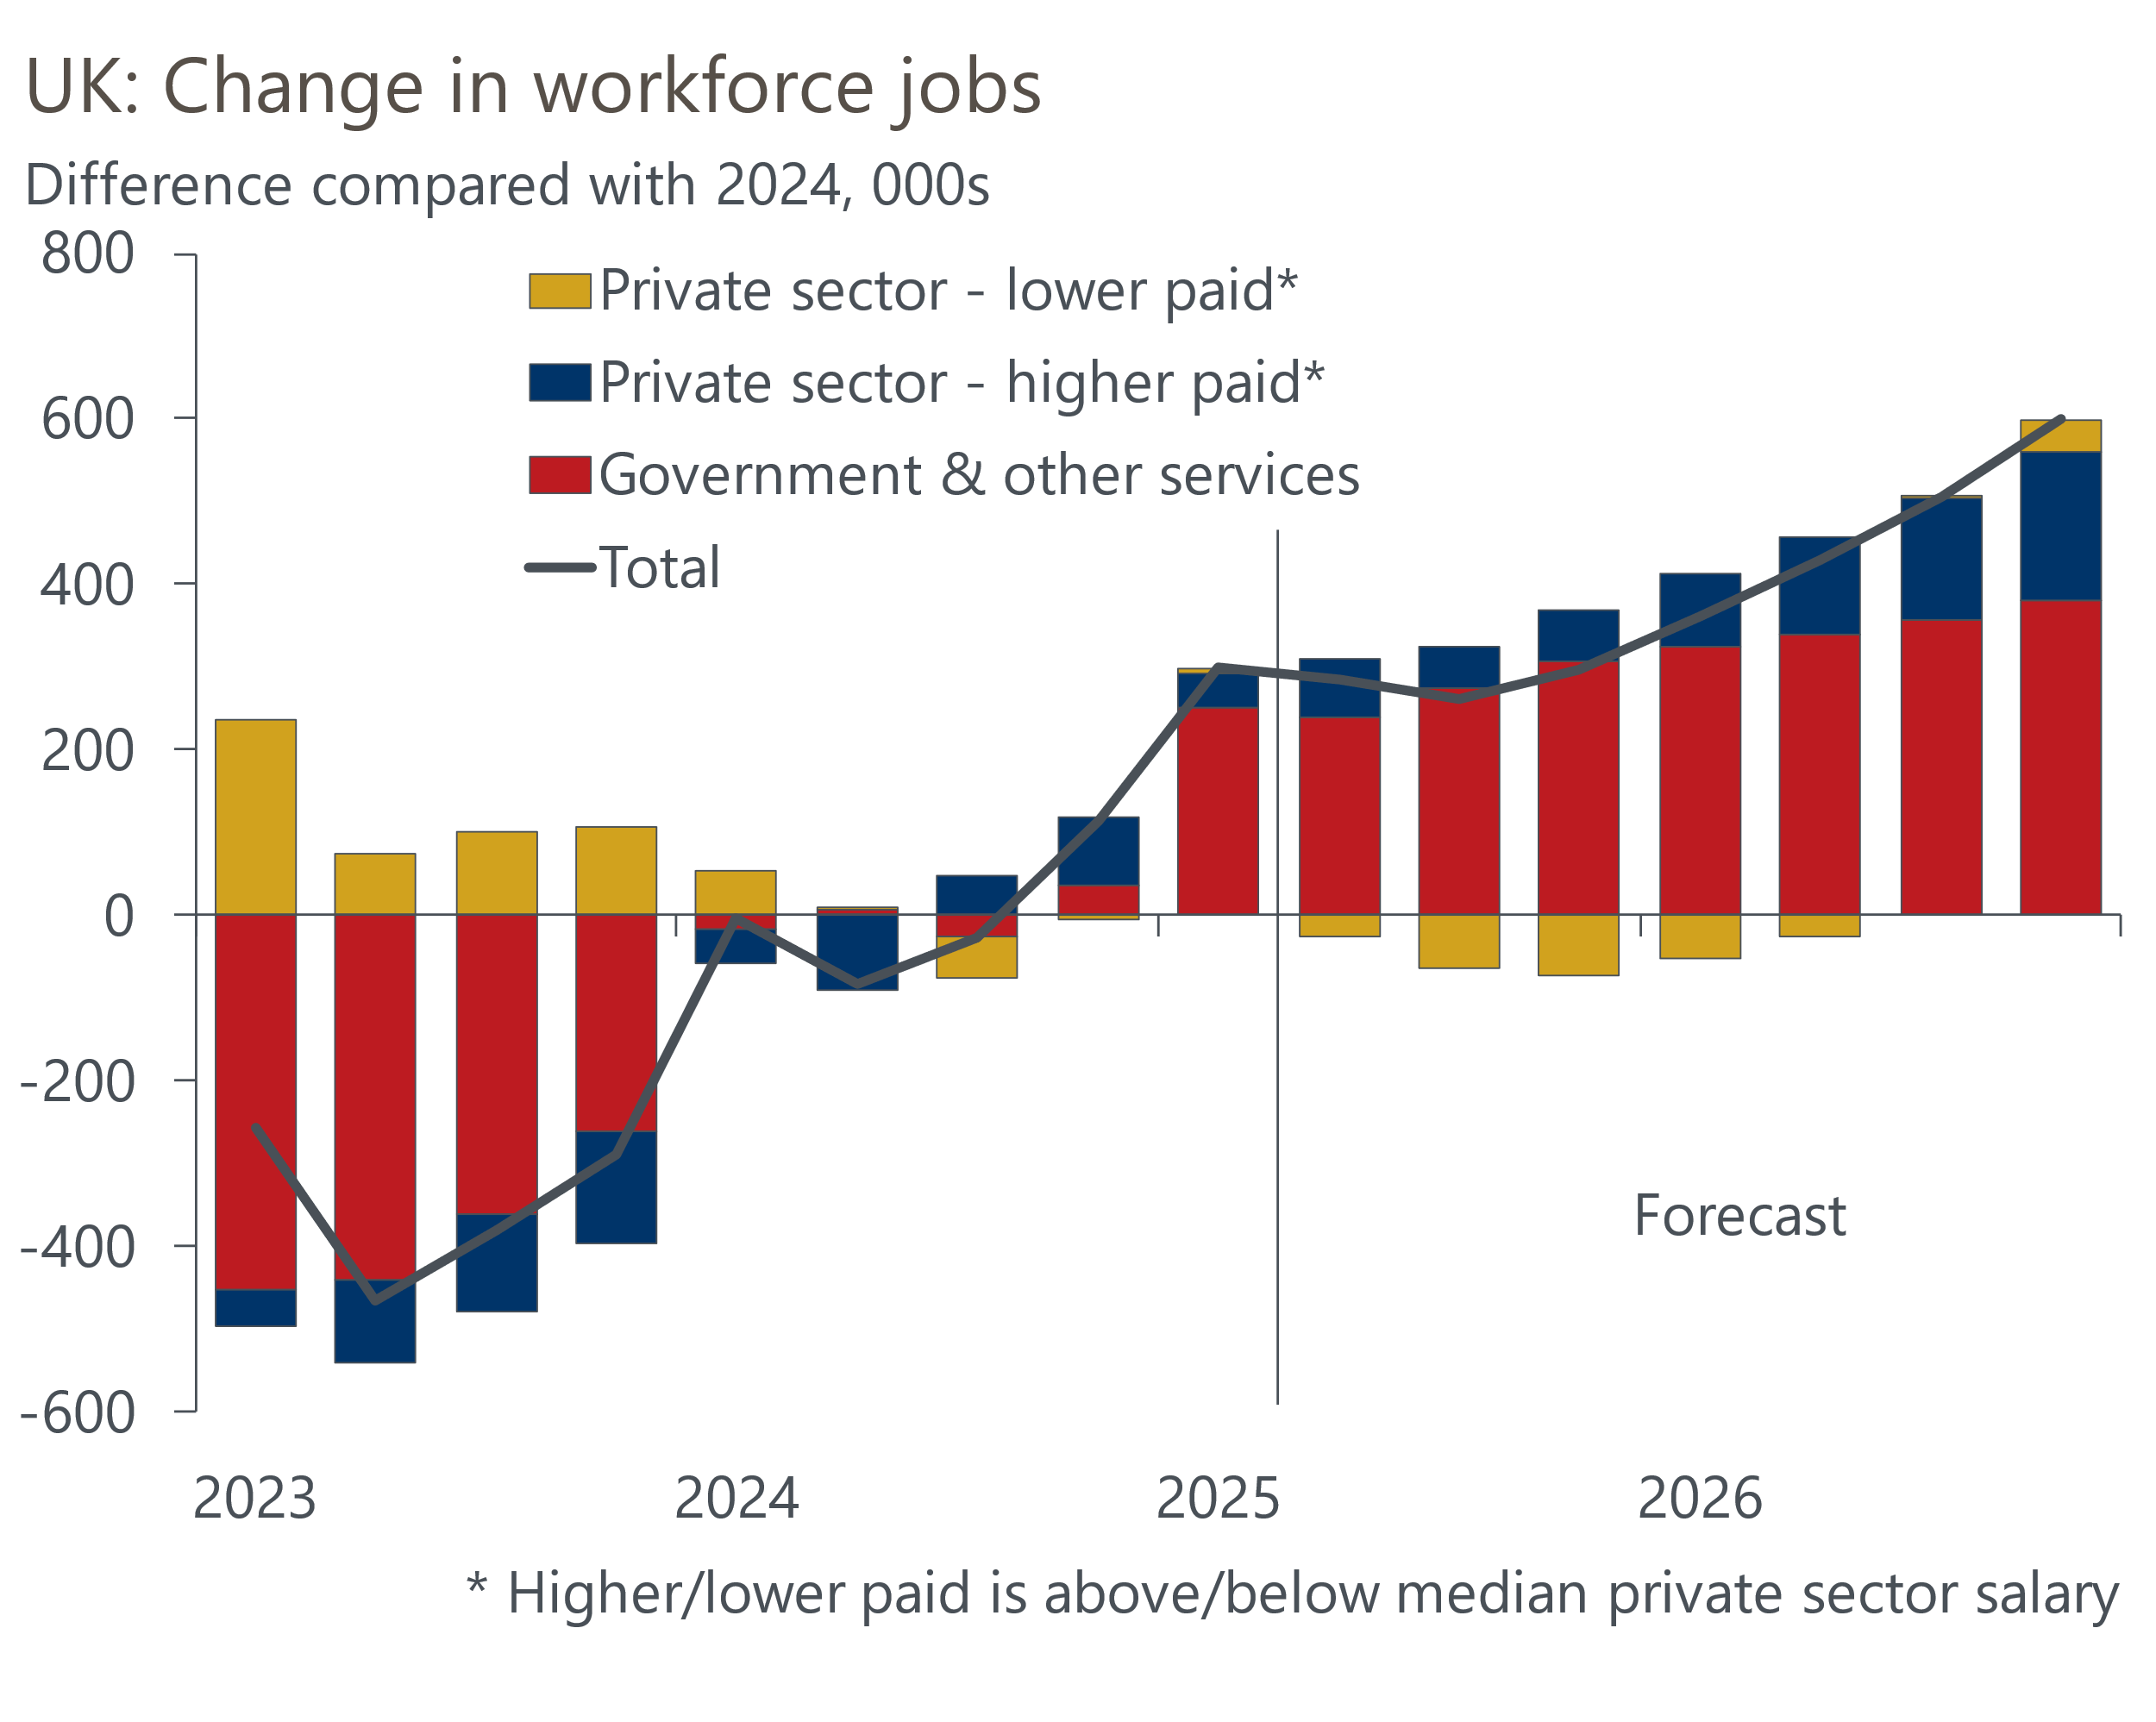
Sources: Oxford Economics, Haver Analytics

Despite enduring two major recessions, the UK has enjoyed strong growth in employment over the past 30 years. But the sectoral focus of that job creation has been relatively narrow. More than four-fifths of the 9mn net increase in jobs between 1994 and 2024 came in the business services and finance and government and other services sectors (Chart 2; see Box 1 for more information about how we have aggregated sectors).
Chart 2: The public sector has accounted for most of the net job creation since 2019
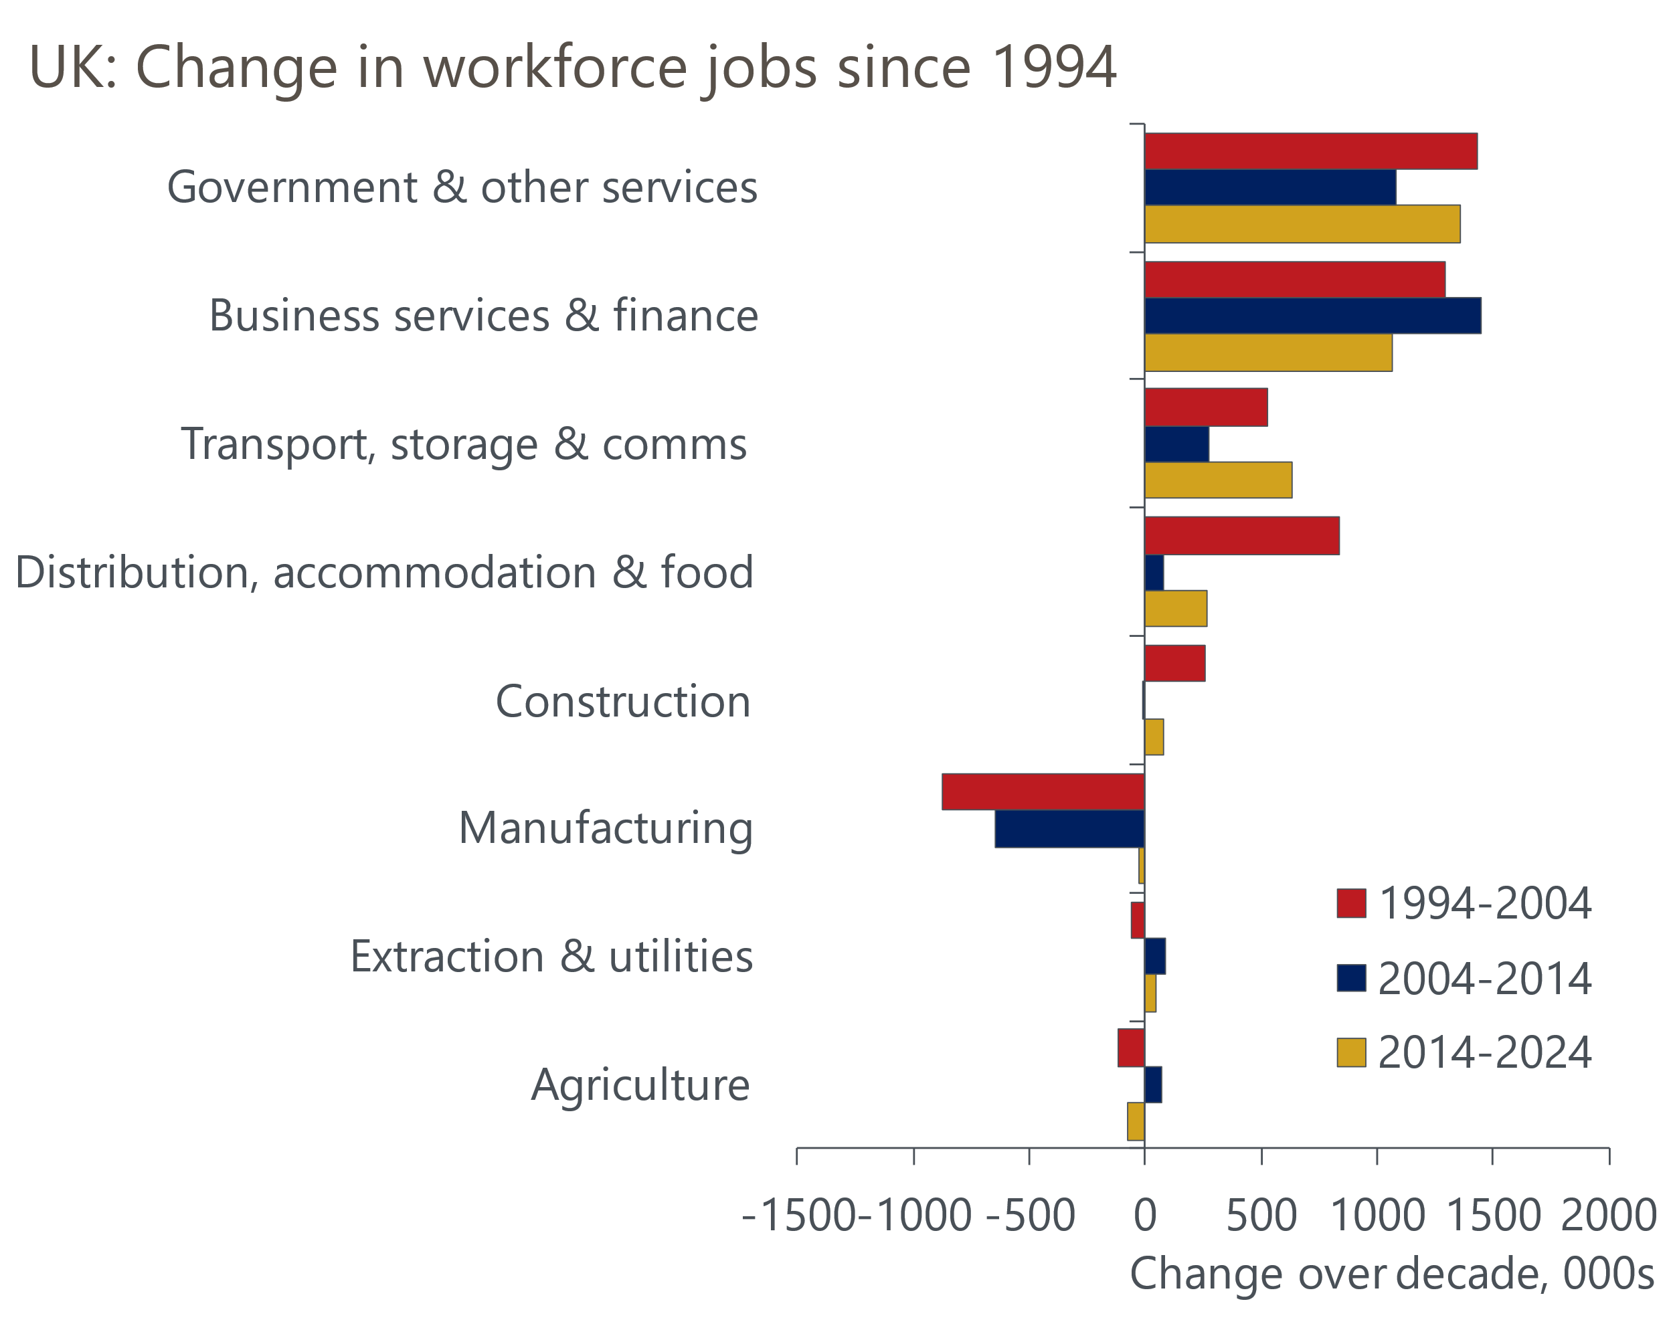
Source: Haver Analytics
That period also saw the loss of more than 1.5mn manufacturing jobs, though the losses were mostly concentrated in the years up to 2010.
Since 2019, the sectoral focus has narrowed further. The health sector has been responsible for just under half of the net 1.5mn jobs created since 2019. When public administration and education are added, industries that are dominated by the public sector account for 72% of the net job creation since the pandemic started.
By contrast, large parts of the private sector continue to struggle – around a third of sub-sectors have lower employment now than in 2019. These sectors include wholesale and retail, manufacturing, construction, and administrative services – all large employers that collectively account for just over a third of UK jobs.

Tighter spending plans suggest public sector job creation will slow
Strong public sector job creation over the past five years has been sustained by a large increase in government spending, with departmental spending rising from 17% of GDP in fiscal year 2019/20 to 19% of GDP in 2024/25. The extra current government spending announced in the October 2024 Budget should drive further strong job creation in the public sector this year. But thereafter, departmental spending plans are much tighter (Chart 3). This is particularly the case for day-to-day spending, which will be most tightly linked to public sector employment.
Chart 3: The government plans much greater spending restraint from next year
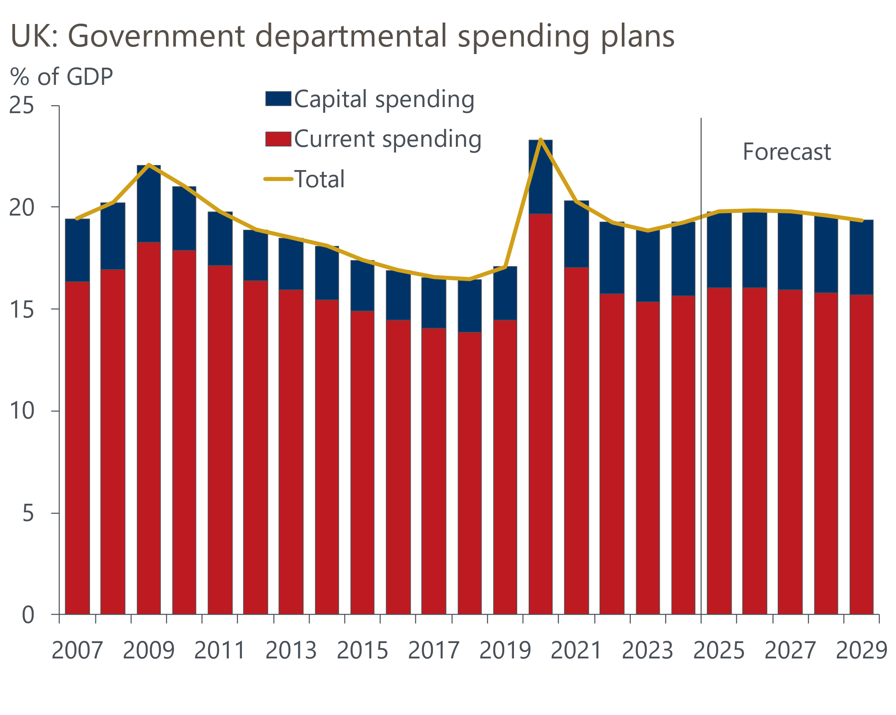
Source: Office for Budget Responsibility
However, tighter spending restraint is likely to mean slower jobs growth rather than outright falls in headcount. Under the 2010-2015 Conservative-Liberal Democrat coalition, the ratio of departmental spending to GDP fell by almost 4ppts, but the number of public sector jobs still rose slightly over this period.
The increasing focus of public sector employment on healthcare also suggests that job creation should continue (Chart 4). In Q1 2025, 35% of public sector employees worked in the National Health Service, up from 29% a decade earlier. The political importance of public healthcare has left it largely immune to funding cuts in recent years – we think this is likely to continue to be the case.
Chart 4: Public sector employment has become progressively more focused on the NHS
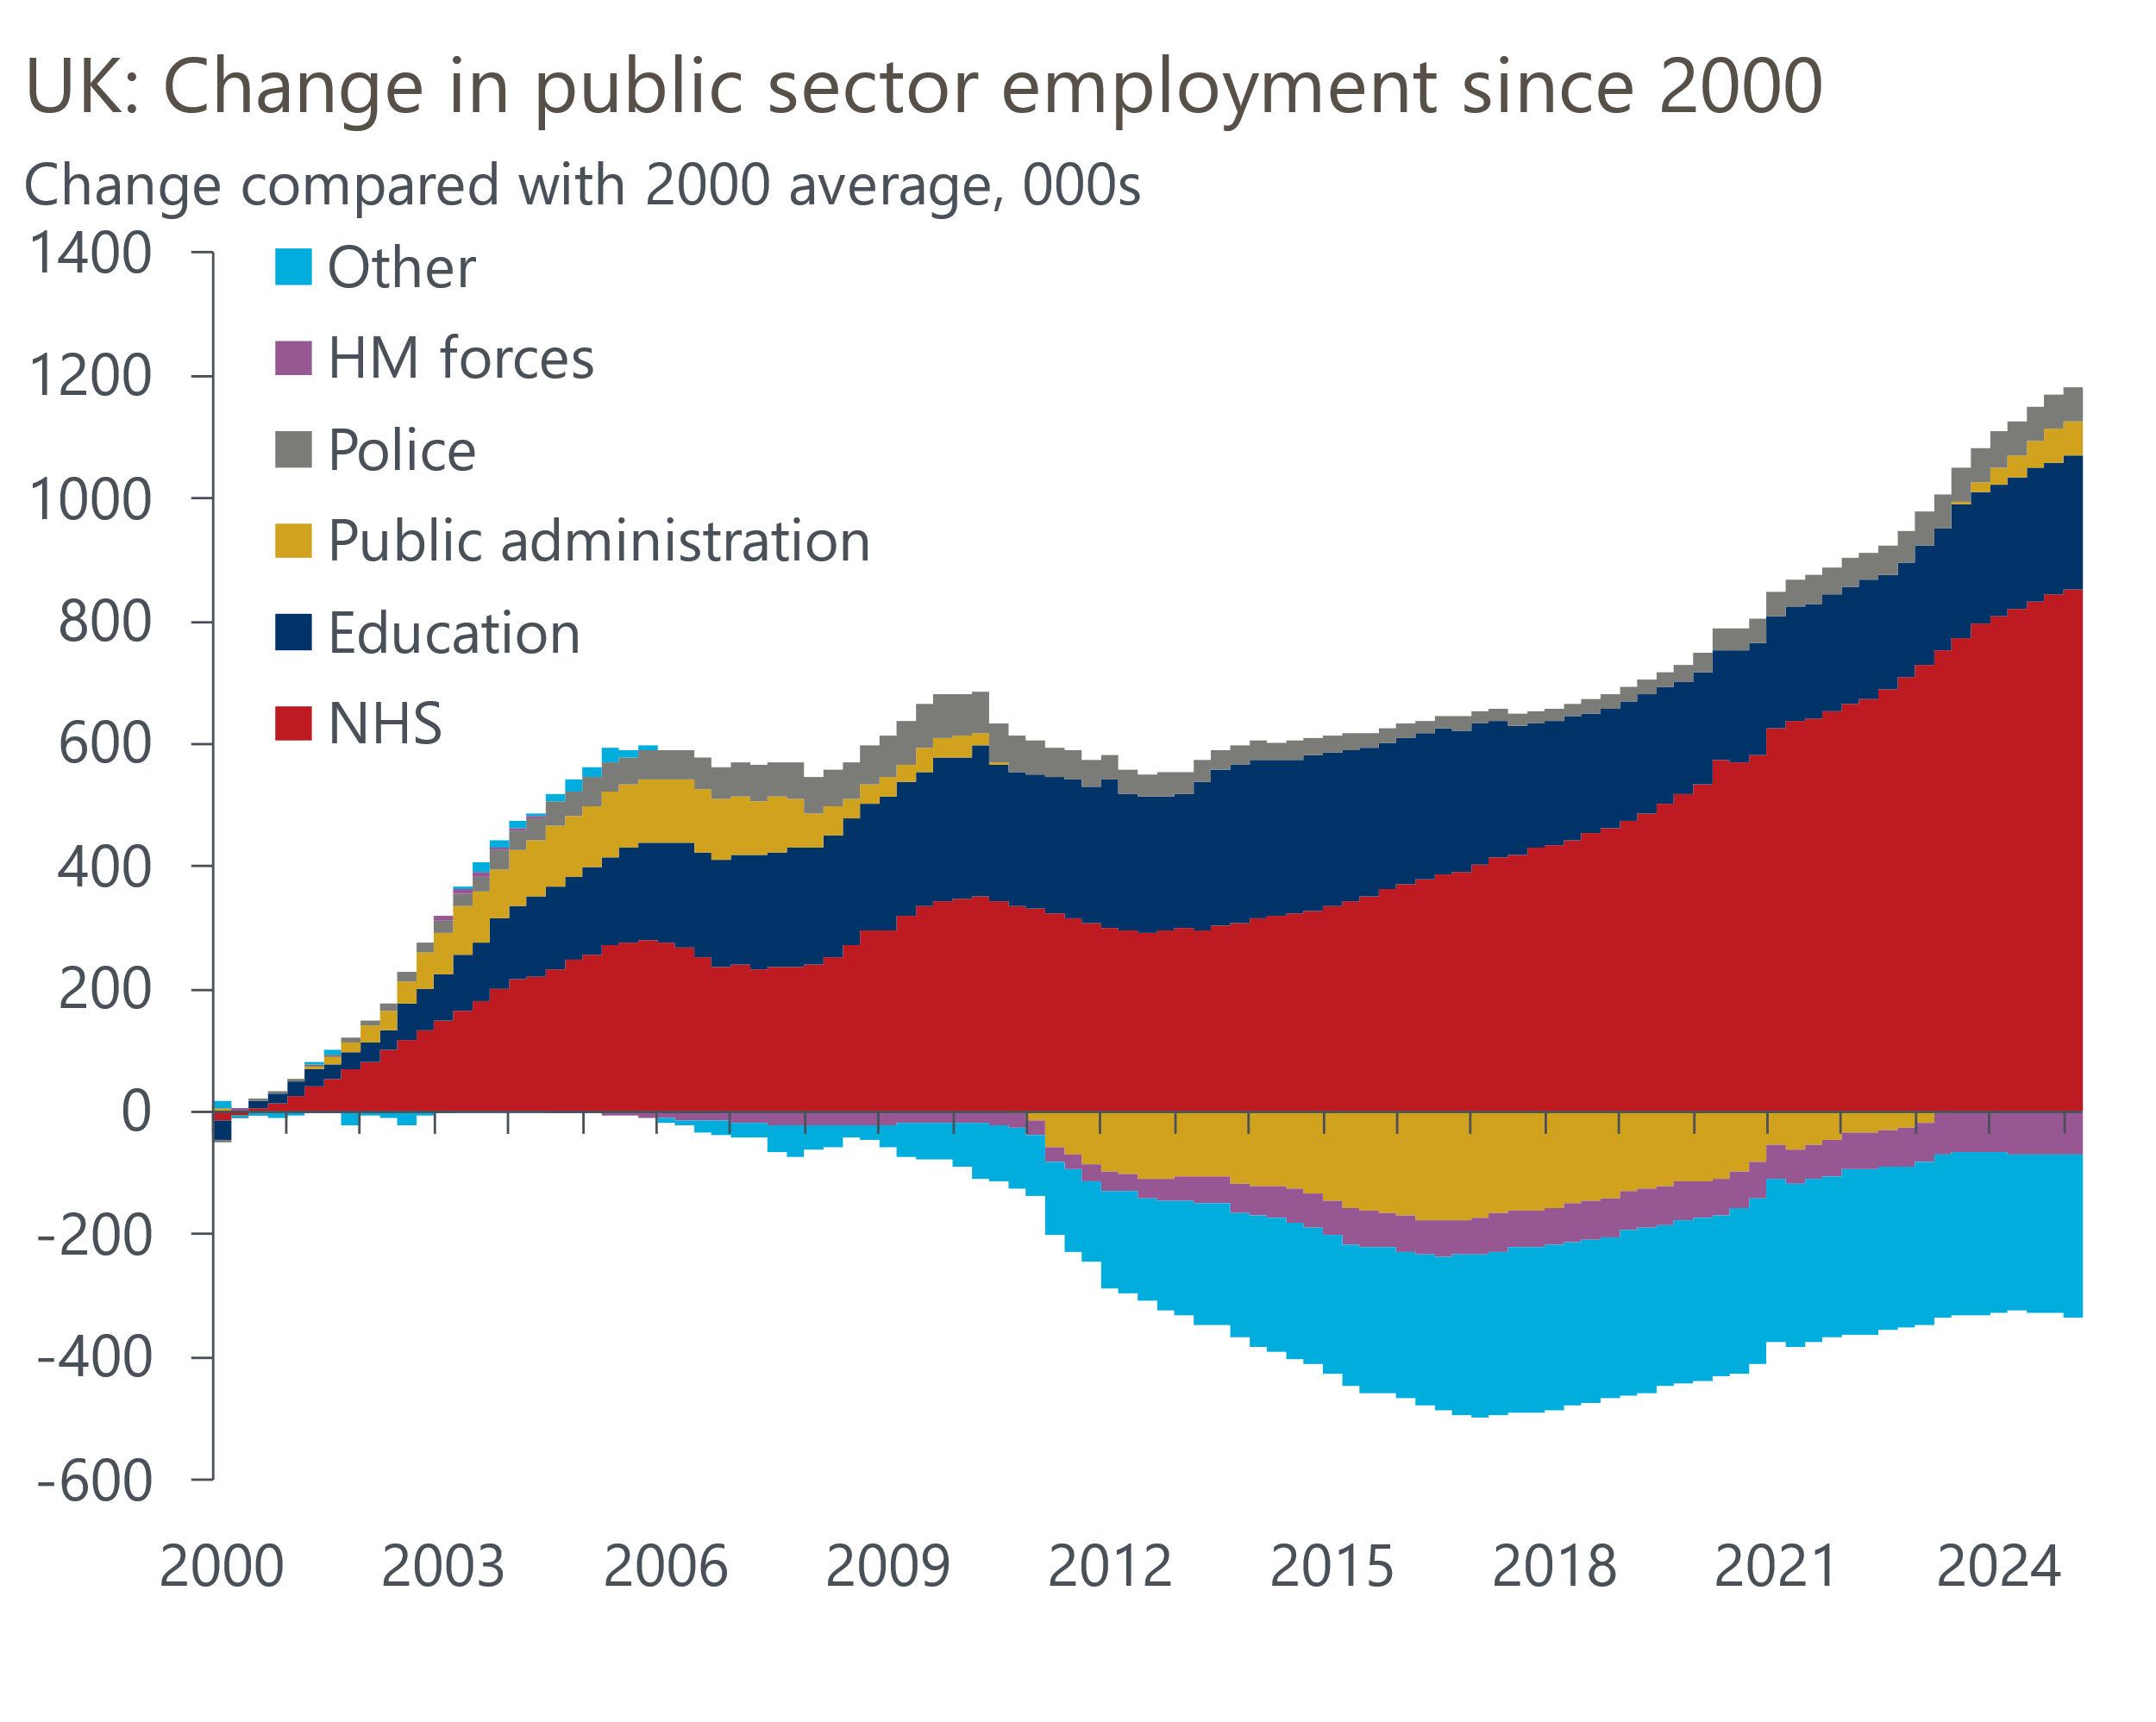
Source: Haver Analytics
In its recent Spending Review, the government aimed to make substantial efficiency improvements to raise output without the need for continued large increases in the health sector pay bill. But the level of healthcare productivity in 2024 was the same as it was in 2012, so we're sceptical that the sector can achieve these efficiency improvements. Experience suggests that the government will likely respond to any failure to improve efficiency by increasing spending on the NHS.

Private sector employment is falling due to sluggish demand and surging labour costs
The prospect of waning support from the public sector puts a much greater onus on the private sector to drive jobs growth. But in the near-term we doubt the private sector can pick up the slack, given the combination of relatively weak demand, the substantial increase in labour costs caused by April's increases in employers' NICs and the NLW, the broader squeeze on corporate profitability, and heightened uncertainty caused by US trade policy.
We are now beginning to get early data on employment and wages for the period since the NICs and NLW increases kicked in. HMRC's count of employees on company payrolls has been falling on a month-on-month basis since November, but the April and May drops were by far the largest of that run. There's been a tendency for early HMRC estimates of employee numbers to be revised up over time, but the scale of recent drops suggests the weakness is unlikely to be fully revised away.
Moreover, as we feared would happen, the sectoral breakdown points to severe pressure in sectors heavily reliant on lower paid roles (Chart 5). Accommodation and food, which pays the lowest median salary, saw the biggest fall in employment on a three-month-on-three-month basis in May. Other services, agriculture, and wholesale and retail are other low-paying sectors that saw substantial job losses.
Chart 5: Sectors more reliant on lower paid roles have seen the biggest job losses so far
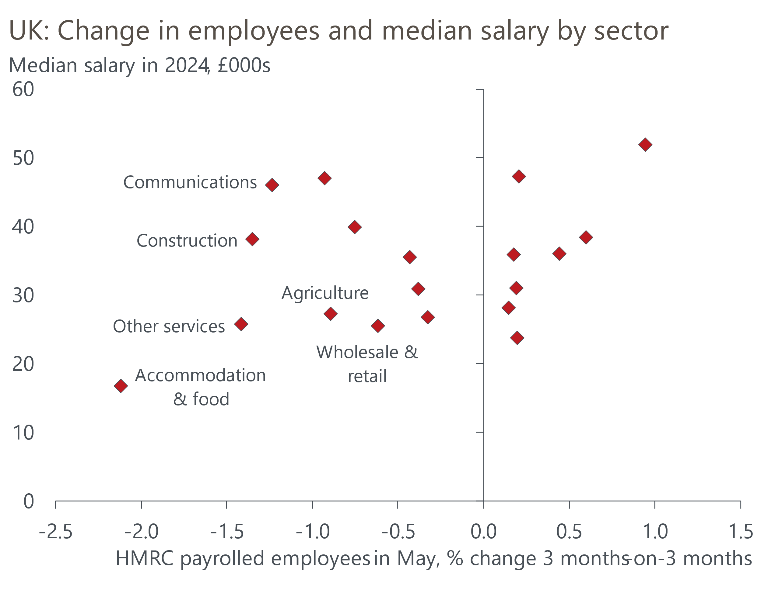
Source: Oxford Economics calculations using data from Haver Analytics & ONS
Data on unfilled vacancies suggest the recent sectoral pattern of employment is largely a labour demand story. Lower paid sectors report the biggest falls in the vacancy ratio (the ratio of the number of unfilled vacancies per 100 jobs) compared with the average of the past ten years, with accommodation and food and other services also the worst performers on this metric (Chart 6).
Chart 6: Lower paid sectors also report weaker demand for workers
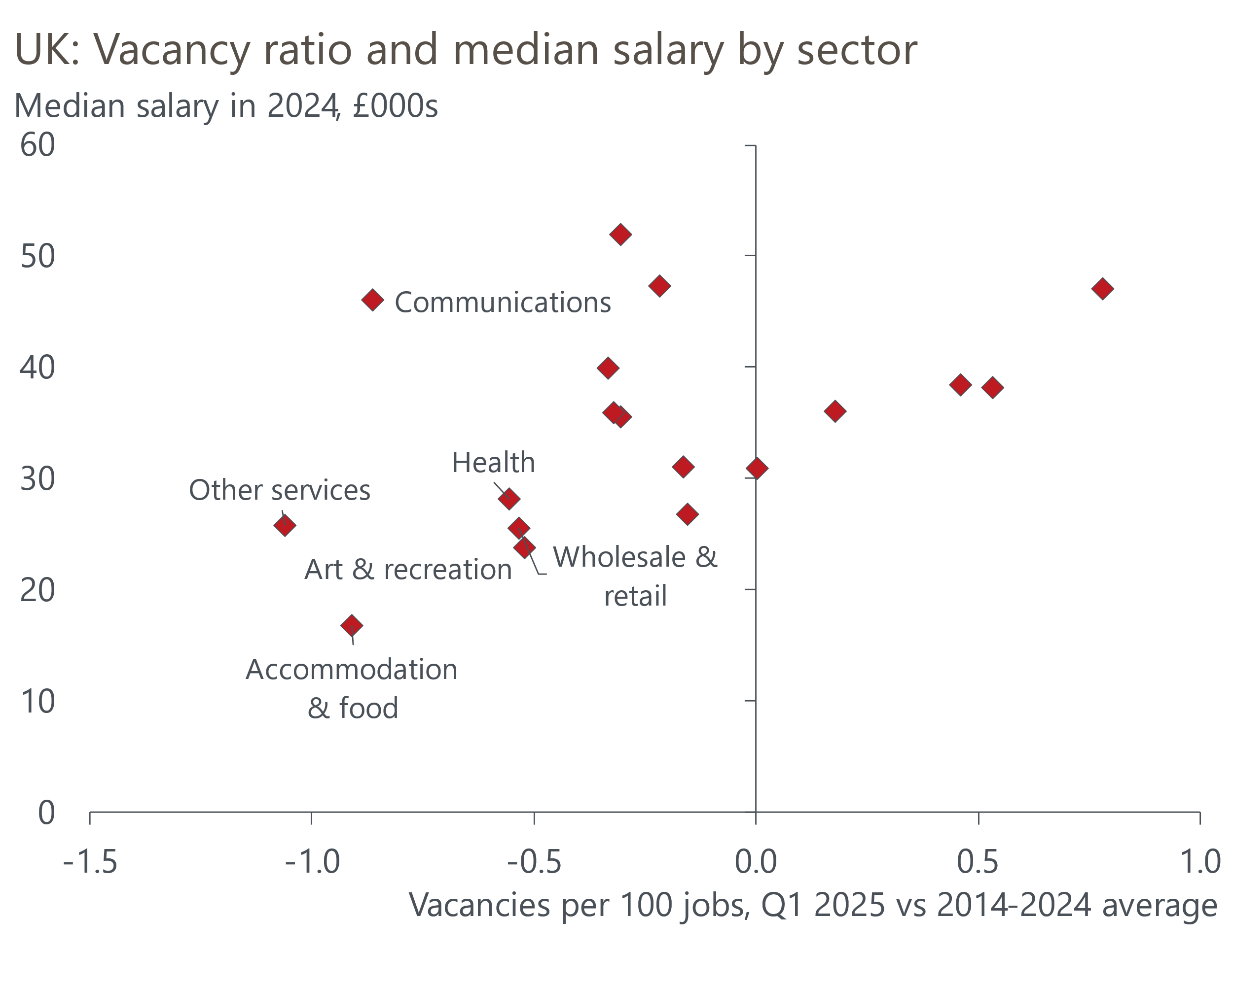
Source: Oxford Economics calculations using data from Haver Analytics & ONS

Labour cost pressures should begin to ease from next year
In our previous note, we estimated that the cost of employing a low paid full-time worker rose by more than 40% between 2021-2025. This was due to the combination of a succession of large pay rises, reflecting consecutive big increases in the NLW and a tight labour market, and the increase in employers' NICs. The final leg of that increase appears to have caused more pressure on firms' finances than the earlier phases.
We expect future increases in labour costs to be smaller. The increase in NICs will probably not be repeated, while pay growth is cooling as the labour market loosens. We also expect a much smaller increase in the NLW from April 2026. The government is yet to issue its remit to the Low Pay Commission, but with the NLW already at two-thirds of median earnings – the previous target – future NLW increases should be more closely linked to average pay growth.
As a result, we think this year's fall in employment in lower paid sectors is more of a one-off adjustment to the build-up in cost pressures than the beginning of a persistent decline in job numbers. But the recovery in private sector job creation is likely to be slow, particularly given that demand is also likely to remain weak.

Waning public sector job creation and weak private sector demand to push up unemployment
Overall, we expect total employment to dip through the rest of this year, as job losses in lower-paid sectors more than offset further job creation in the public sector (Chart 1). Accommodation and food and wholesale and retail are forecast to be the worst performing sectors.
But the trend should turn around in 2026. We expect employment in lower paid sectors to stabilise and then gradually start to pick up. Better-paid parts of the private sector should see a steady increase in headcount, with construction, professional services, and communications expected to lead the way. So although we expect the pace of public sector job creation to cool a little, a slow recovery in private sector employment should ensure that total employment picks up.
Still, if our forecast plays out, the number of private sector jobs at the end of next year would still be lower than it was at the start of the pandemic. And given still strong growth in labour supply, the anaemic recovery in employment means we expect that unemployment will continue to drift upwards in the near-term, peaking only in H2 2026 at close to 5%. This would be 0.5ppts higher than the unemployment rate in Q1 2025 and would indicate a looser labour market than we've been accustomed to for most of the past decade.
The prospect of further loosening in labour market conditions is one of the factors behind our call that the Bank of England's Monetary Policy Committee will cut Bank Rate more than financial markets anticipate during 2026. The combination of soft employment and cooling pay growth will also slow the momentum behind real household income growth, ensuring that the recovery in consumer spending continues to underwhelm.

Box 1: Sectoral breakdown used in this note
This note focuses on the Office for National Statistics' workforce jobs series. This measures the number of jobs, rather than the number of people employed. Though this measure uses the problematic Labour Force Survey for its estimates of self-employment, the data on employees is collected from employers and is generally accepted to be superior to the sectoral data for employees collected from the LFS.
We produce forecasts for 20 sectors at the SIC 2007 section level. But in several places in this note, we have aggregated the sectors into eight categories to aid comparisons. The sectoral breakdown is as follows:
Agriculture (SIC section A)
Extraction and utilities
SIC section B – Mining and quarrying
SIC section D – Electricity, gas, steam and air conditioning supply
SIC section E – Water supply, sewerage, waste and remediation activities
Manufacturing (SIC section C)
Construction (SIC section F)
Distribution, accommodation and food
SIC section G – Wholesale and retail trade, repair of motor vehicles and motor cycles
SIC section I – Accommodation and food service activities
Transport, storage and communications
SIC section H – Transport and storage
SIC section J – Information and communication
Business services and finance
SIC section K – Financial and insurance activities
SIC section L – Real estate activities
SIC section M – Professional, scientific and technical activities
SIC section N – Administrative and support service activities
Government and other services
SIC section O – Public admin and defence, compulsory social security
SIC section P – Education
SIC section Q – Human health and social work activities
SIC section R –Arts, entertainment and recreation
SIC section S – Other service activities
SIC section T – People employed by households

